**ReactPHP REST API Documentation**

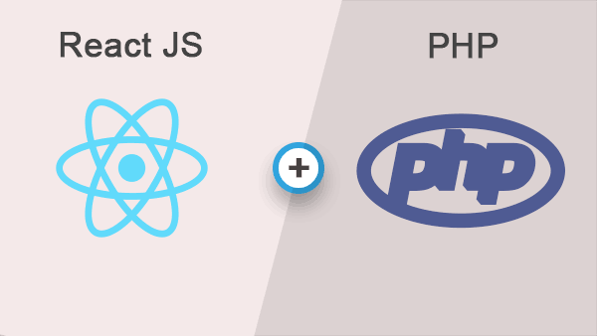

**© Copyright | Author manuelExtra**

* **Environment (Application Environment)**

env.php

**Application Name**

**APP_NAME**

The Application Name constant holds the name of the Application. Here the name (suitable or befitting name) that shows up on the tab is specified here.

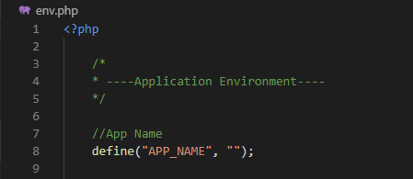

**DB_NAME**

**Database Name**

The Database Name constant for MySQL holds the specific name of the database created and to be used for the application.



**Database Password**

**DB_PASSWORD**

The Database Password constant holds the password of the database username.



**Database HostName**

**DB_HOST**

The Database HostName constant holds the Database server hostname. The MySQL hostname will be localhost by default.



**DB_USER**

**Database Username**

The Database Username is specified in the constant. For a successful connection, the right password and username must be supplied to their respective constants.

